# BCLA Website Accessibility Guide

This is a guide to help library workers choose more accessible websites for people with disabilities.

Disabilities are limitations caused by a mismatch between a person and their environment. For example, a wheelchair user is limited in a space with no ramps.

Disabled people can have a variety of health conditions, including those affecting seeing, hearing, mobility, flexibility, dexterity, pain, learning, developmental, mental health, memory, and more.

Accessibility is how likely something is to be usable by disabled people.

This guide describes six things to check on a website to get an idea of how accessible it is.

These checks are some of the simpler ways to find some of the biggest accessibility problems on a site but are not enough for a complete accessibility test.

While passing these checks is a good sign indicating that there are at least some features which help support people with disabilities, it does not mean that a website is completely accessible.

At the end of the guide, there is a table showing the checklist results for some kids’ websites.

## Website Accessibility Checklist

* 1. Accessibility Information  
  The website provides information on its accessibility goals, features, and limitations, as well as information on how to report accessibility problems.
* 2. Accessibility Scan  
  An automated scan shows the website has no accessibility errors.
* 3. Animations  
  The website has no animations that start on their own.
* 4. Media  
  Images, audio, and video have text alternatives.
* 5. Zoom  
  The website is enlarged and can still be used when zoomed in 400%.
* 6. Keyboard Control  
  The website can be controlled with just a keyboard (no mouse or trackpad).

### 1. Accessibility Information

Website creators who put effort into making their site more accessible will probably tell you about it.

Accessibility information will usually be on its own page. If this page exists, you can usually find it through a link at the bottom of the website, or through a web search.

**Tip: You can specify which site to search in Google by including ‘site:’ and the website’s URL in your search terms.**

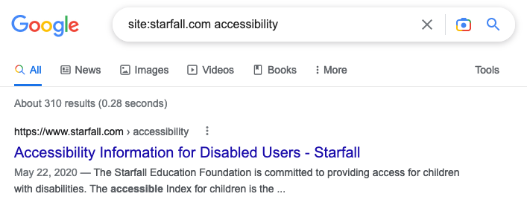

Google search results for ‘site:starfall.com accessibility’.

The accessibility page may include an accessibility statement. An accessibility statement describes the site’s accessibility goals, features, and limitations, as well as instructions on how to report accessibility problems.

Having an accessibility statement does not guarantee that the website is accessible, or that everything in the statement is accurate. However, it does suggest that the website creators have put some effort into accessibility and may give useful details about the website’s accessibility.

### 2. Accessibility Scan

Automated accessibility scanners can find many, but not all, accessibility problems on a web page.

There are many accessibility scanners out there, with different features and levels of detail. Web Accessibility Evaluation Tool (WAVE) by WebAIM is one of them.

WAVE (<https://wave.webaim.org/>) is a free online accessibility scanner that does not require any downloads to use. It can only check one page at a time. When checking accessibility for a whole website rather than a single page, try to scan the home page and at least a couple other pages.

To use WAVE, copy and paste the web page’s URL into the ‘Web page address’ field and hit the enter key or press the arrow button to the right of the text field.

The results page shows the results of the scan on the left side, and a marked-up preview of the web page on the right side.

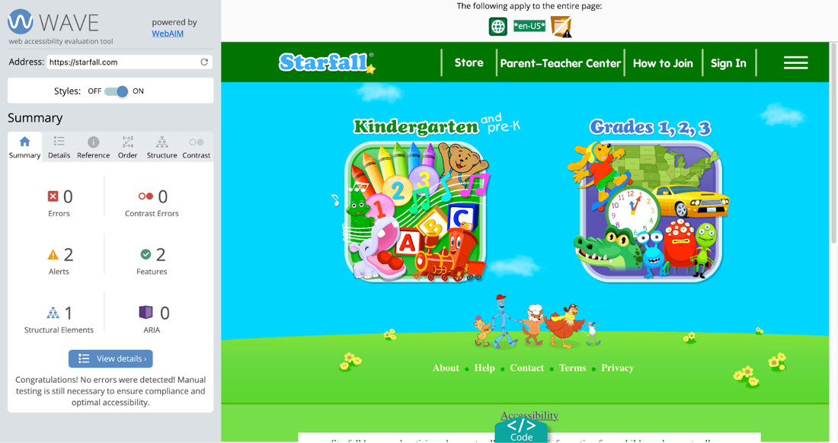

WAVE results page for ‘https://starfall.com/’ showing 0 errors and 0 contrast errors.

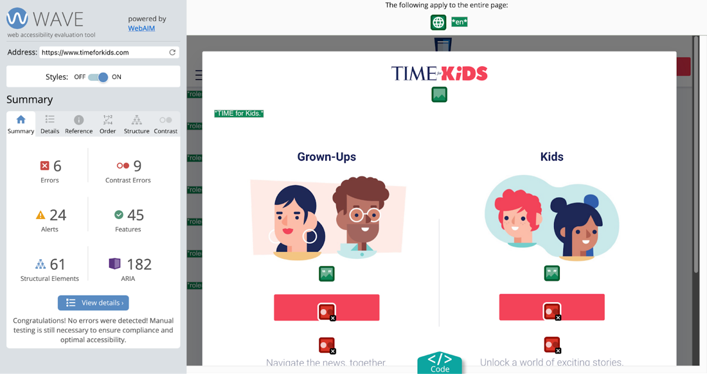

WAVE results page for ‘https://timeforkids.com/’ showing 6 errors and 9 contrast errors.

The most important accessibility problems this scanner can find will be counted as ‘errors’ and ‘contrast errors’ and shown at the top of the summary tab content. If there are any errors or contrast errors, it is likely that the page has accessibility barriers, especially for blind and low vision users and users of assistive technology.

### 3. Animations

Animations (like videos, GIFs, or other moving content) can be distracting or even outright dangerous. They can be a huge barrier for people who have difficulties with memory or focus. Animations can even trigger seizures or other severe reactions in some.

Websites should not have any animations that start playing on their own.

### 4. Media

Media like images, videos, and audio are visual and auditory by nature. Many people with visual and auditory disabilities cannot enjoy such media if they don’t come with text versions.

Images (other than ones that are purely decorative) should have text descriptions, videos should have captions, and audio should have captions or transcripts.

Images may have visible text descriptions next to them, or they may have invisible text descriptions that can be read by assistive devices.

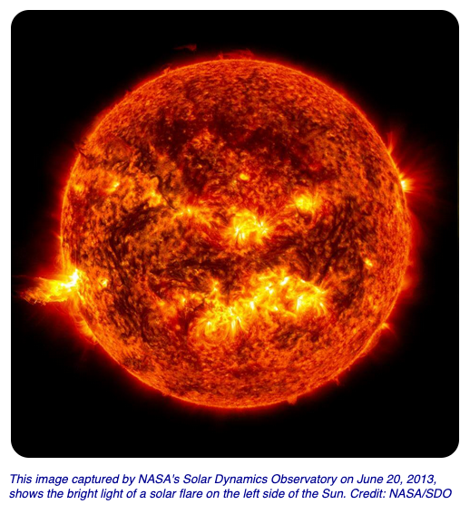

An image with a visible text description from NASA SpacePlace All About the Sun.

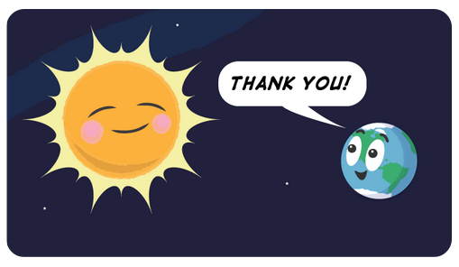

An image with an invisible text description from NASA SpacePlace All About the Sun.

**Tip: A quick way to check if an image has an invisible text description is to highlight the image and copy and paste it into the URL bar. If the image has a text description, that text will appear in the URL bar.**

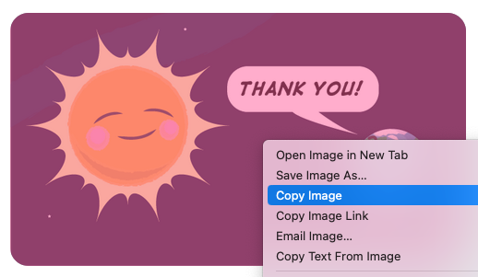

The previous image from NASA SpacePlace All About the Sun highlighted and right clicked.

Text in a search bar that says "Cartoon of the Sun looking happy and the Earth saying thank you!"

When pasted into the URL bar, the image’s invisible text description appears.

Videos may have open captions that are always visible on the video themselves, or they may have closed captions which can be shown or hidden as needed. Videos with closed captions will usually have a “CC” button in the player’s controls or settings. Clicking this button will hide or show the video’s captions.

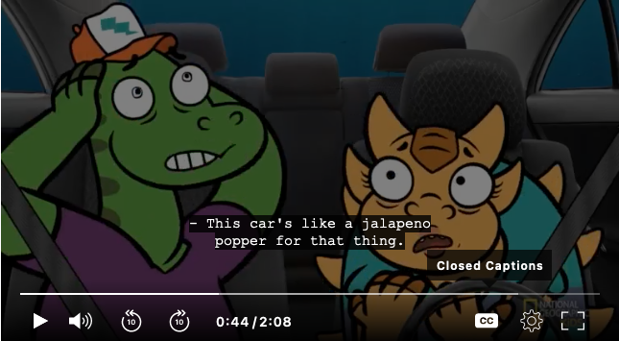

National Geographic for Kids video on Tylosaurus with captions enabled.

Audio transcripts are usually found on the same page as the audio player. The transcript is usually either written out on the page, or there might be a link to the transcript on another page.

### 5. Zoom

Some users, especially those with low vision, will zoom into a web page to use it. It should be possible to zoom a web page to 400% and still be able to use it. When the page is zoomed to 400%, the content should be enlarged, visible, and usable. For example, text should not be covered by other elements and buttons should still be clickable.

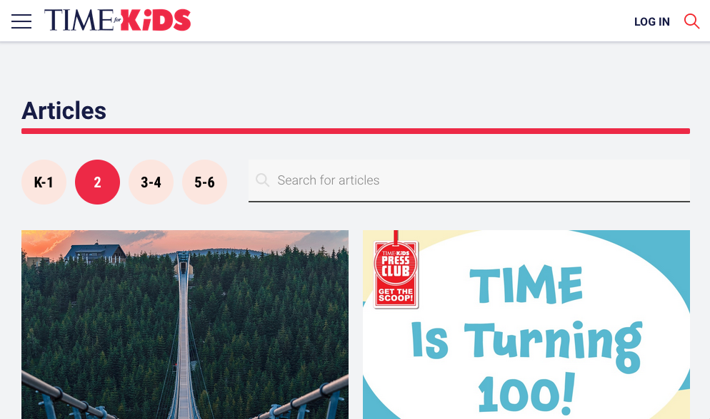

TIME for Kids grade 2 articles page at 100% zoom.

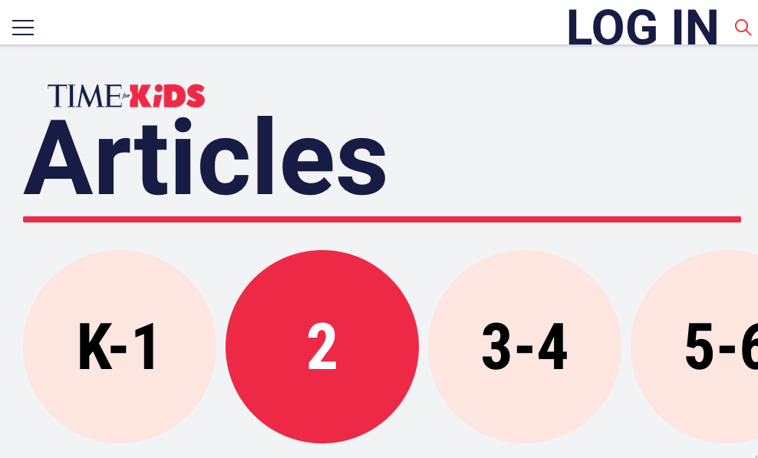

TIME for Kids grade 2 articles page at 400% zoom.

**Tip: Learn how to zoom with a web browser (**[**https://www.wikihow.com/Zoom-With-a-Web-Browser**](https://www.wikihow.com/Zoom-With-a-Web-Browser)**)**

### 6. Keyboard Control

People can use computers with a variety of input devices other than mice and trackpads. Many people with disabilities use keyboards or assistive technology like switches to browse the web. If something can be controlled by keyboard alone (without using a mouse or trackpad), it’s more likely to be able to be usable with other input devices, too.

To check if a site can be used with just a keyboard, try navigating through the interactive elements of a page by hitting the `tab` key. Each interactive element should be visually highlighted in some way, usually with a coloured border. Usually, hitting the `enter` key will activate the interaction. Some more complicated interactive elements like games might have different keyboard controls.

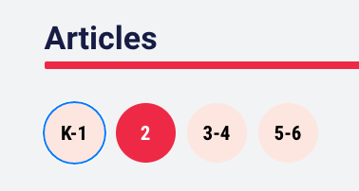

TIME for Kids grade 2 articles page with the K-1 grade level button.

**Tip: If you are using Mac OS and Safari or Firefox, you may need to change some settings for the `tab` key to go through all interactive elements:** [**https://www.a11yproject.com/posts/macos-browser-keyboard-navigation/**](https://www.a11yproject.com/posts/macos-browser-keyboard-navigation/)

## Sample Checklist Results

|  |  |  |  |  |  |  |
| --- | --- | --- | --- | --- | --- | --- |
| **Website** | **1. Accessibility Information** | **2. Accessibility Scan** | **3. Animations** | **4. Media** | **5. Zoom** | **6. Keyboard Control** |
| NASA SpacePlace (<https://spaceplace.nasa.gov/>)  NASA’s website to inspire and enrich upper-elementary-aged kids' learning of space and Earth science online through fun games, hands-on activities, informative articles and engaging short videos. | No accessibility information is provided on the website.  However, NASA’s main website has some accessibility information, and this may be useful: <https://www.nasa.gov/content/accessibility-policy/>. | The homepage and a couple inner pages were checked and found to have errors and contrast errors. | Auto-playing animations were found. For example, the Earth thumbnail on the homepage is animated (<https://spaceplace.nasa.gov/>). | Images have descriptions and videos have captions. | Zooming to 400% does not actually increase the size of all the page content.  Zooming to 400% can hide important content. | Page navigation and videos can be controlled with a keyboard alone.  Games cannot be played with just a keyboard. |
| National Geographic Kids (<https://kids.nationalgeographic.com/>)  Website for kids focused on science and history. | No accessibility information is provided on the website. | The homepage and a couple inner pages were checked and found to have some errors but no contrast errors. | Auto-playing animations were found. For example, a banner video on the Animals page (<https://kids.nationalgeographic.com/animals/amphibians/>). | Images have descriptions and videos have captions. | Zooming to 400% does not actually increase the size of all the page content.  Zooming to 400% can hide important content. | Page navigation and videos can be controlled with a keyboard alone.  Funny fill-ins can be played with just a keyboard, but other games cannot. |
| PBS Kids (<https://pbskids.org/>)  Website with videos and games based on PBS Kids TV shows.  “Time travel” games:  Museum Maker (<https://pbskids.org/xavier/games/museum-maker>)  Dinosaurs games (<https://pbskids.org/games/dinosaurs>)  Space games (<https://pbskids.org/games/space>) | There is no dedicated accessibility page, but accessibility information for some specific games is available here:  <https://www.pbs.org/parents/thrive/supporting-your-child-with-disabilities-with-digital-learning-games> | The homepage and a couple inner pages were checked and found to have errors and contrast errors. | Auto-playing animations were found. | Images have descriptions and games have captions.  Videos cannot be played outside of the US and were not checked for captions. | Zooming to 400% does not actually increase the size of all the page content.  Zooming to 400% can hide important content. | Page navigation can be controlled with a keyboard, but focus is usually not visible.  Videos cannot be played outside of the US and were not checked for keyboard control.  Some games have keyboard controls. This page lists some of them: <https://www.pbs.org/parents/thrive/supporting-your-child-with-disabilities-with-digital-learning-games> |
| Starfall (<https://www.starfall.com>)  Educational website with activities for pre-k to grade 3. | Accessibility information for the site is provided here:  <https://www.starfall.com/h/accessibility.php> | The homepage and enhanced accessible index page (<https://www.starfall.com/h/index-acv.php>) do not have any errors or contrast errors.  There are errors on activity pages, even those listed in the accessible index page. | There is a loading animation between pages. | Closed captions are available for songs and nursery rhymes.  Transcripts and visual descriptions for some activities are provided here: <https://www.starfall.com/h/transcripts.php> | Zooming to 400% does not actually increase the size of all the page content.  Zooming to 400% can hide important content. | Much of the site cannot be controlled with just a keyboard.  Activities that can be used with only a keyboard are listed here: <https://www.starfall.com/h/index-acv.php> |
| TIME for Kids (<https://www.timeforkids.com/>)  TIME magazine’s website for kids in grades K-6. | No accessibility information is provided on the website. | WAVE shows errors and contrast errors. | No auto-playing animations were found. | Audio has transcripts.  Videos have captions.  Images don’t all have descriptions. | Zooming to 400% increased the size of page content and no content was hidden. | The site can be navigated with a keyboard only.  Videos can be controlled with a keyboard only.  The ‘read aloud’ feature cannot be controlled with only a keyboard. |
| Timestorm podcast (<https://www.cocotazomedia.com/timestorm-about>)  A middle-grade time-travel fiction podcast series. | No accessibility information is provided on the website.  Kids can listen to the podcast with their preferred podcast listening app, which would have different accessibility information. | WAVE shows errors and contrast errors.  Kids can listen to the podcast with their preferred podcast listening app, which would have different scan results. | The page has a podcast player with scrolling text.  Kids can listen to the podcast with their preferred podcast listening app, which would have different animations. | The page provides transcripts for its podcasts.  Kids can listen to the podcast with their preferred podcast listening app, which should have show notes with a link to these transcripts. | When the page is zoomed to 400%, some of the controls on the podcast player are partially obstructed. However, they can still be used.  Kids can listen to the podcast with their preferred podcast listening app, which would have different zoom results. | The links and podcast player on this page can be controlled by keyboard alone. However, it’s not very visually clear where the keyboard focus is.  Kids can listen to the podcast with their preferred podcast listening app, which would have different keyboard control results. |

*Prepared February 2023 for BC Library Association by Matsuko Friedland, CPWA*